Chapter 19, Problem 63.

Determine the z parameters of the two-port in Fig. 19.110.

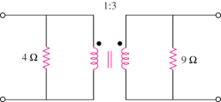

Figure 19.110
For Prob. 19.63.

